- Introduction
Site suitability analysis is important in delineating appropriate sites for various developmental initiatives. Binary models use logical expressions to select target areas from a composite feature layer or multiple rasters. The output of a binary model is in binary format.1 or true for areas that meet the selection criteria and 0 or false for areas that do not. The Raster based method requires the input rasters, with each raster representing a criterion. A local operation with multiple rasters can be used to derive the raster-based model from the input rasters. This project was based on the criteria that the collin county government wants to select potential industrial sites that meet the following criteria; at least 5 acres in size, commercial zones, not subject to flooding, not more than 1 mile from a heavy-duty road and less than 10 % slope. This is done in four different stapes.
- Gathering all layers(land use, flood potential, road, and slope) which is important to the county criteria mentioned above.
Land Use data: I used the county website and downloaded the parcels. This data has the legal area footage and all other attributes that can be used to fulfill the information needed for site selections.
Flood potential: a shapefile downloaded from the county website which is normally used to see the risk of flood for insurance or other purposes.
Road network: a shapefile that has all kinds of roads downloaded from the collin county website, but since we are looking for heavy-duty roads, only the state Hwy and US Highways were extracted from this original downloaded data. And since we are looking for sites that are 1 mile from those heavy-duty roads it was necessary to create a buffer around the road layer.
2. Intersecting the road buffer zone layer and other layers. Intersect, instead of other overlay operations, can limit the output to areas within one mile of heavy-duty roads.
3. Write a query for the composite feature layer for potential industrial sites.
4. Select the sites which are equal to or larger than 5 acres.

II. Literature review
Two articles were reviewed for this project and here are the reviews for each article.
Silberman and Rees (2010) built a GIS model for identifying possible ski towns in the U.S. Rocky Mountains. They examine the characteristics of existing ski areas, before the selecting location criteria. Characters include annual snowfall, potential Ski season, Influence of global warming on future snow data, distance to national forests, and accessibility. Information on the location of commercial airports was taken to see the accessibility for potential ski travelers who could be coming from near and far. Access to reach a market was represented by a resort's proximity to the nearest settlement of 10,000 to a city of 50,000 population and available airport. Querying the reduced settlement database and evaluating each settlement as a potential site, this set of selection is then applied to all populated settlements in the Rocky Mountain region. The balanced ranking approach was taken to identify final candidates.

Isaac et al. (2008) use a procedure similar to the construction of binary models for predictive mapping of powerful owl breeding areas in urban Melbourne, Australia.
The eastern Melbourne study site was queried using overlay analysis to intersect combinations of the common ecological variables. To develop the selection criteria, the first stape was to buffer existing breeding sites with a distance of 1 Km and then intersect these buffer zones with data layers of tree density, hydrology, vegetation classes, land use zone, and slope. After analyzing ecological attributes within the buffer zones they select a distance to water (40mt) and tree cover locating potential breeding sites of powerful owls.

III. Study Area and Data Sources
This project was done in the Northern part of Texas in the US which is located at 33°11′N 96°35′W. Collin county is a resident for 1.035 million people according to the 2019 US Census, making the county the seventh most populous county in Texas and the 45th largest county in the US by population. It has an area of 841 sq mi of land and 45 sq mi of water. Allen, Anna, Blue Ridge Farmersville, Lavon, Lowry Crossing, Lucas, Mckinney, Melissa, Murphy, Nevada, Parker, Princeton, Weston are cities that are in the county.
For this project a sample of area shown in a square was taken.
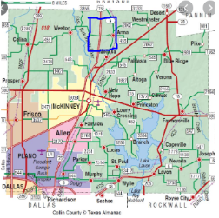
IV. Analysis/ Methodology
The project was done by building a binary model that identifies site selection for industrial sites that is based on the criteria the government wants that were mentioned above: at least 5 acres in size, commercial zones, not subjected to flooding, not more than 1 mile from a heavy-duty road, and less than 10% slope.
For these criteria, I gathered information from different sources.
The first resource for most of the data was the county website which was very informative and easy to use. The other one was Data.gov, TIGER/Line Shapefile,USGS.gov, and USDA.gov.
The datasets used are land use data which is parcels shapefile,which has all information about a site in its attribute. It has polygons with address, Zip Code, mail deliverable or not, legal squarefootage, etc…
Commercial zones have a designated number by the county and this is found in attributes of the parcel. For my purpose, I used vacant commercial land code which is 300 in the parcel.
Flooding information gathered from the Collin county flood plain, which is a database used to show the flood risk for collin county.
DEM was used to calculate slope. The source was USDA.gov. A spatial calculation was done on this data to create a slope shapefile.
Once all the data was gathered, model builder was used to select sites that can fulfill the mentioned conditions.
Flow chart
- At least 5 acres in size
- Commercial zones
- Not subjected to flooding
- Not more than 1 mile from heavy-duty roads
- Less than 10% slope
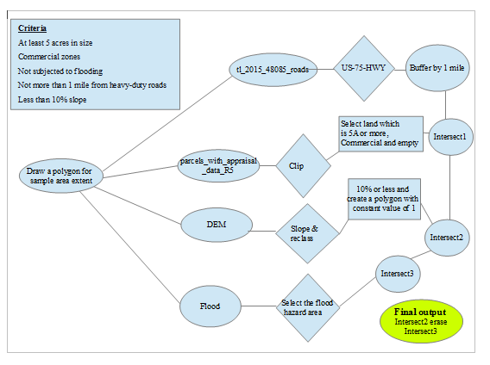
To do the analysis, first draw a polygon that is going to represent the sample area, and make it the extent of analysis. I cliped the parcel using the polygon used as the extent so that I know the exact location the analysis for the parcel layer which reduces confussion.
Create a new shape file in the catalog in the folder of the project. And then draw a polygon that is the extent of the analysis.
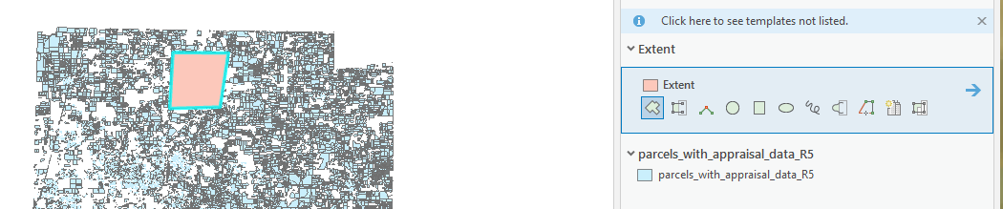
Select the US 75 HWY from the attributes and make a layer out of this selections and export this data calling it US-75-HWY.
Buffer US-75-HWY by 1 mile according to the criteria.
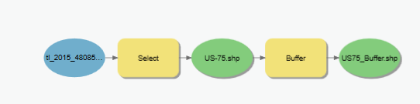
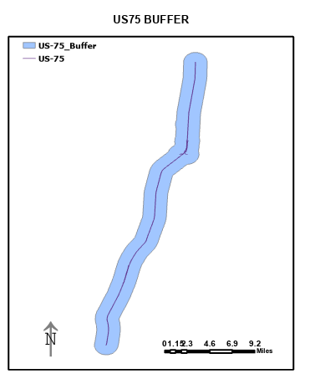
The intersection of US-75-HWY buffer and the cliped parcel creates parceles that is with in 1 mile.
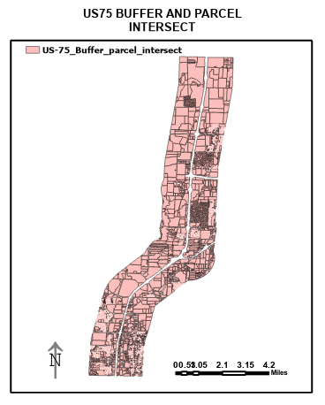
Slope is also calculated from the DEM layer. Slope is then reclassified into two 1 for slope less than 10% and 0 for slope greater than 10%. the result is majority of the
slope is below 10% throughout the county. Their are only 20 cells out of 561,086 cells total.Then select the areas with slope less than 10%, and creaste a polygon for the area.
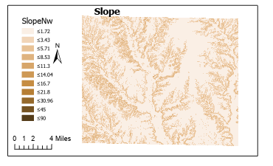

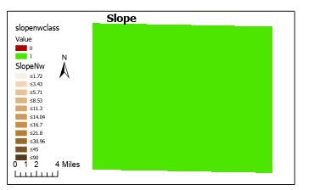
Model Bulder query and Selection by attribute is done to select the qualified land in the sample area.

Using model builder I queried the land type, that would fulfill the criteria.
According to 96-313 Texas Property Tax Assistance Property Classification Guide , property classifications include
C1: Real Property: Vacant Lots and Land Tracts
C2: Real Property: Colonia Lots and Land Tracts
D1: Real Property: Qualified open _space land
D2: Real Property: Farm and Ranch Improvements on Qualified open_space land.
F1: Real Property: Commercial
Using the above information to select the qualified lands.
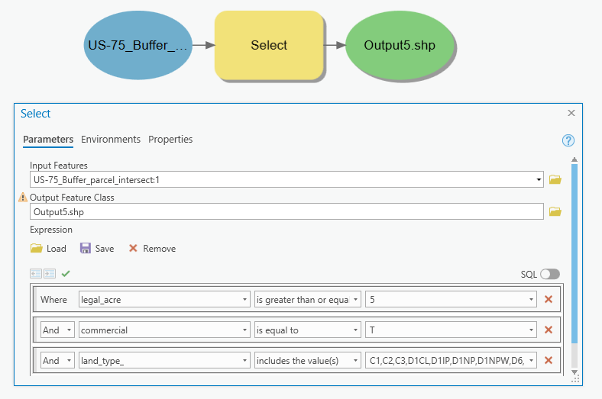

Intersecting the filtered parcels with the slope polygon layer will give us all the parcels that fulfill the requirement, except the flood.Which will be discused later.
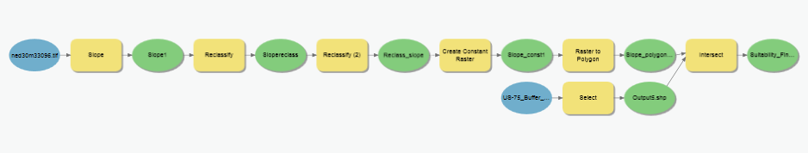
Parcels that where selected for the critera befor intersection and after intersection with the slope.

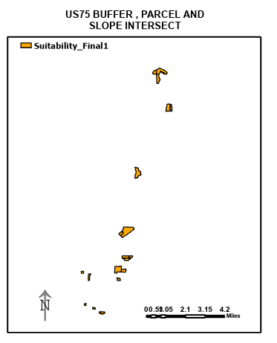
Flood was another requirement by the county and the data gathered was GIS_Vector1.CCDL.S_FLD_HAZ_AR_PRELIM. The information in the data suggested that the 1 to 0.2 PCT is low risk area but the AE, floodaway is a high risk so I selected high risk area using model builder.
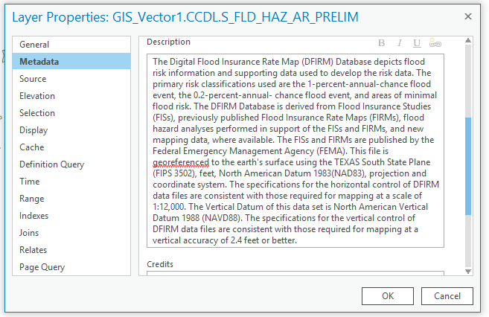
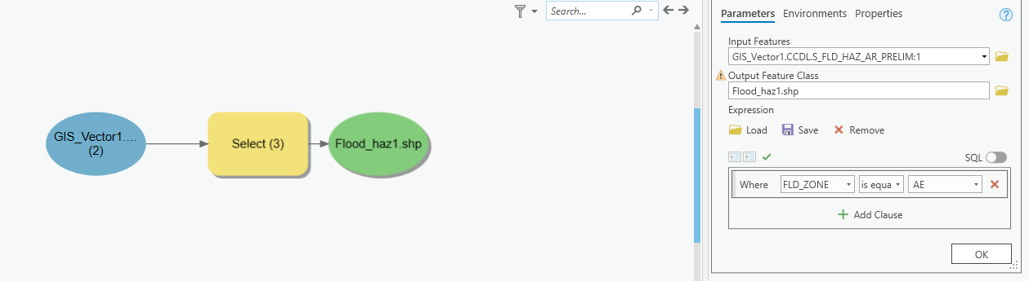

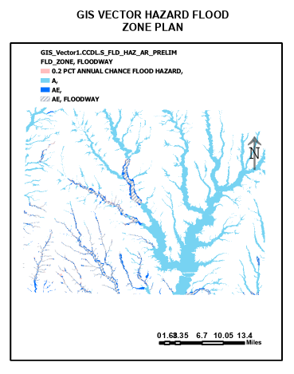
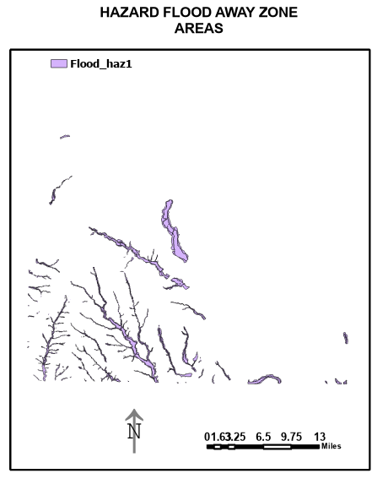

The selected parcels which where qualified for slope and land requirements
where intersected with the flood hazrd layer dirived from the flood layer. The out put was named suitability_final1_intersect.
Then used the select layer by location tool to select parcels that are in crossed by the intersected out put from flood and parcel intersection. A layer where created from the selection and subtracted from suitability_final1 layer.

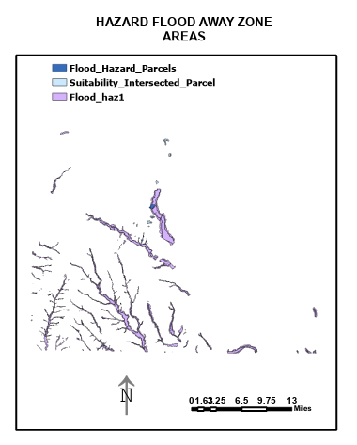
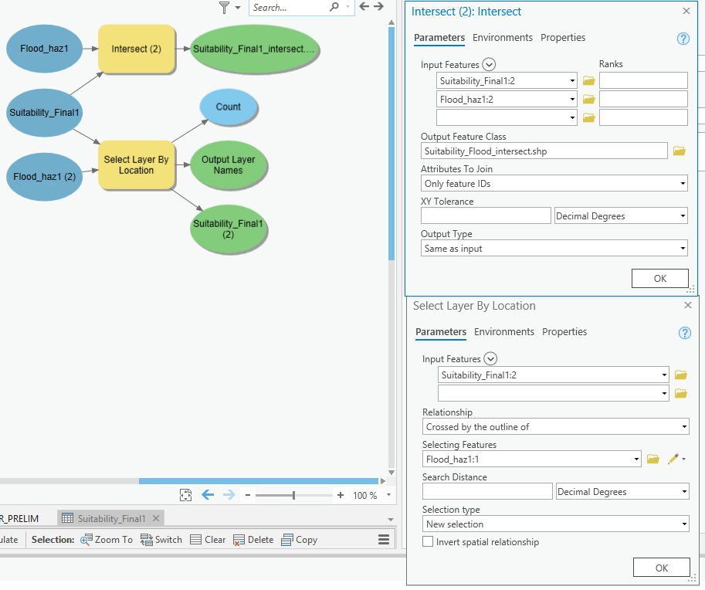
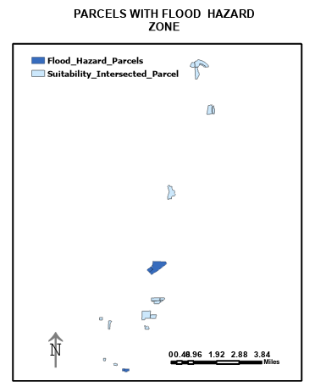

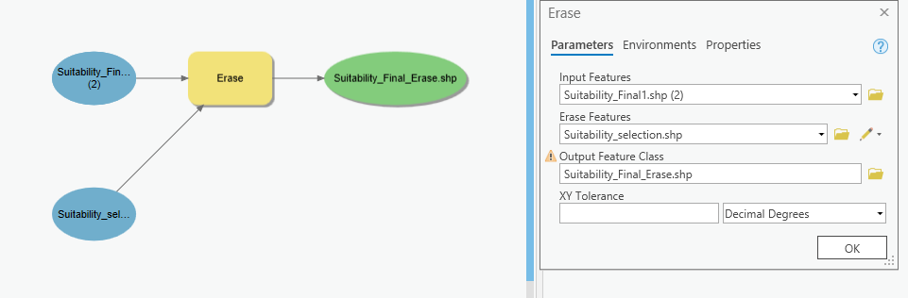

Result
From the 12,430 parcels GIS has selected 22 final output are picked for the sample area in collin county.
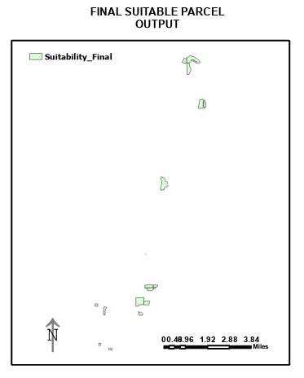
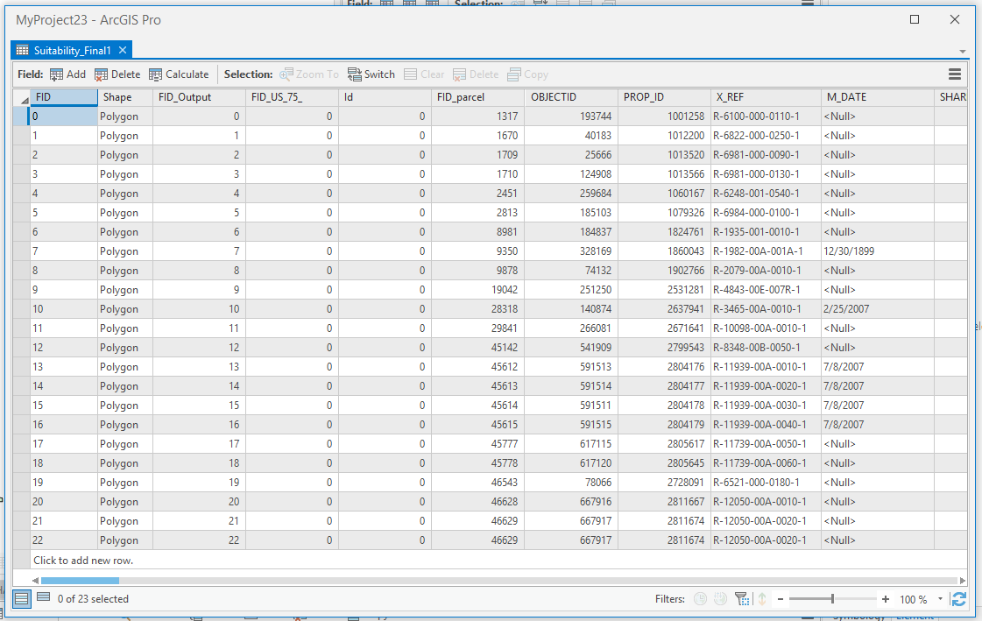

Reference
Silberman, Jordan A ; Rees, Peter W. (2010, January). Reinventing mountain settlements: A GIS model for identifying possible ski towns in the U.S. Rocky Mountains
https://www-sciencedirect-com.libproxy.utdallas.edu/science/article/pii/S014362280900071X

Bronwyn, Isaac; Raylene, Cooke; Dianne, Simmons; Fiona, Hogan. (2008, March, 3). Predictive mapping of powerful owl (Ninox strenua) breeding sites using Geographical Information Systems (GIS) in urban Melbourne, Australia.
https://www-sciencedirect-com.libproxy.utdallas.edu/science/article/pii/S0169204607001831

USDA.Gov
https://datagateway.nrcs.usda.gov/GDGOrder.aspx?order=iMapOrder

USGS.gov
https://www.usgs.gov/

Collin County, Texas. (2020, June 20). In Wikipedia
https://en.wikipedia.org/wiki/Collin_County,_Texas

Collin county central appraisal district
https://www.collincad.org/downloads/viewcategory/16-gis-downloads

Collin County Flood Plain 2011
https://www.arcgis.com/home/item.html?id=93fd3328a8cb4242aab52ac901139c25

Data.gov
https://catalog.data.gov/dataset/tiger-line-shapefile-2019-series-information-for-the-primary-and-secondary-roads-state-based-sha04e7

